DIS-PAC-POLY-HI-Poi Pounder

This ancient Hawaii Poi Pounder has been in my family for over two hundred years, from the time The white marks you see on the Pounder is from lying in the taro water. There is no cracks, solid Blue Pahoehoe Lava Rock. If you are a serious collector, you will not be disappointed in this item.  It is very heavey and solid. This poi pounder is even older as it does not have the knob on top.

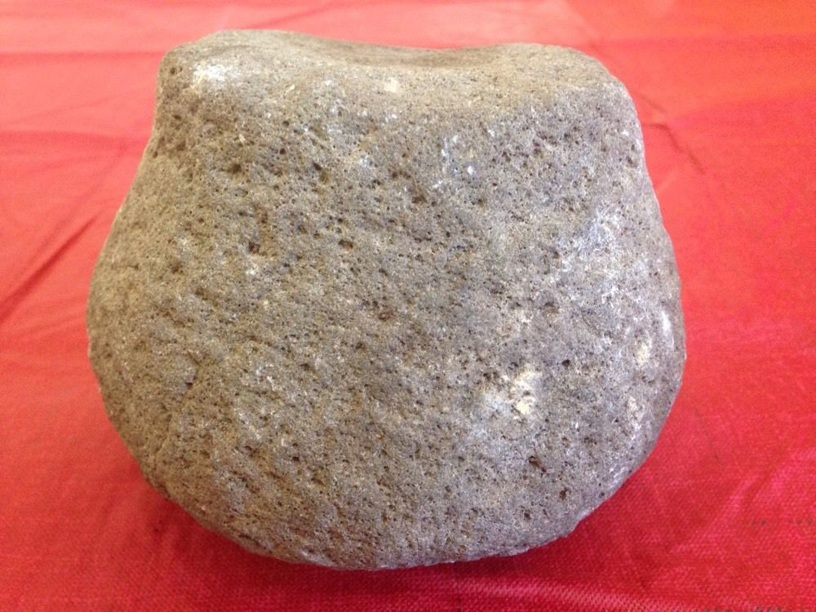

**This accent Hawaii Poi Pounder/Grinder has been in my family for over two hundred years, from the time of King Kamehameha the Great.**

**The base of this Poi pounder/Grider is approximately 5 inches high.  This Poi Pounder/Grider is in Excellent Condition.  There is no cracks, solid Blue Pahoehoe Lava Rock.**

